USER REQUIREMENTS

The Bidder should provide the following in the specified order in Section 4 of the proposal/bid document.

Provide detail information of the proposed solution as per document enclosed. Please note that marking should be carried out in the following manner; The Remarks column should be used to explain or provide detail information.

DESCRIPTION | REMARKS
Rating - 5 | If the User requirement is met 100% as defined in the RFP without any work around method.
Rating - 4 | If the User requirement is met 75% as defined in the RFP without any work around method. Define the number of hours required for the modification and cost in US$ in the Remarks column, in order to provide 100% functionality as defined.
Rating - 3 | If the User requirement is met 50% as defined in the RFP without any work around method. Define the number of hours required for the modification and cost in US$ in the Remarks column, in order to provide 100% functionality as defined.
Rating - 2 | If the User requirement is met 25% as defined in the RFP without any work around method. Define the number of hours required for the modification and cost in US$ in the Remarks column, in order to provide 100% functionality as defined.
Rating - 1 | If the User requirement is met as a Work around method defined in the RFP. Define the number of hours required for the modification and cost in US$ in the Remarks column, in order to provide 100% functionality as defined.
Rating - 0 | If the User requirement is not met as a defined in the RFP and modifications are required. Define the number of hours required for the modification and costs in US$ in the Remarks column.

The NBL rating is as follows:
1 = critical; 2 = essential; 3 = nice to have

Cash Back Term Loan snap shot
Ref | User Requirements of Special Deposit Products | Bidder’s Rating | Bidder’s Remarks
 | For every loan there should be review date input screen | 4 | All T24 applications and transactions can be retrieved easily by using enquiry designer, where the user can define what kind of information are needed to be printed in the reports or to be viewed
 | Rate change letter, Balance confirmation letter | 5 | T24 has facility to define the schedule when the system should product notices  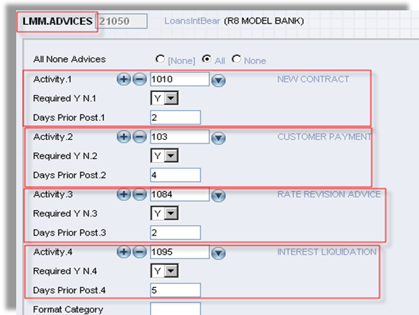  Figure 1. Flexible Advices trigger setup
 | Repayment Schedule | 5 | Supported by T24
 | What are collaterals for given loan | 5 | T24 Collateral module allows definition and handling of different types of collateral.
 | Deposit rate & loan rate combination  e.g.  Deposit rate + rate margin % =lending rate  Fixed rate  Cash back lending rate | 4 | Handled by T24 interest rate tables. May require some local enhancement.
 | To identify the facilities with special rates & the tenor with special rate | 5 | Handled by T24 Loan product designer tables.
 | Need a free text area to input remarks/comments | 5 | Narrative are provided normally for the various T24 input tables.
 | Provision provided in the system for change of security to another (e.g. fixed Deposits, savings a/c, treasury bills, treasury bonds, Treasury bill repo, treasury Bonds and corporate paper) should update | 5 | Handled by T24 Collateral module.
 | Request reports,  “Refer MIS Requirement” | 5 | Handled by similar standard T24 MIS reports.

